

**CANDIDATE BRIEF**

**NIHR Academic Clinical Lecturer in Paediatrics**

**Faculty of Medicine and Health**

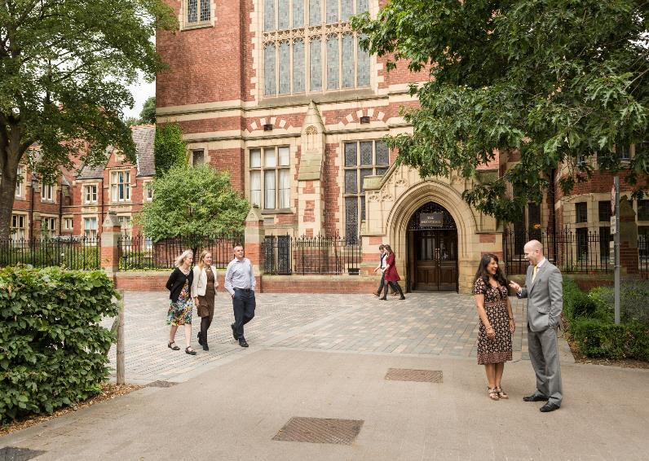

**Salary awarded depending on trainee’s current NHS pay scale and pay protection status under transitional arrangements (£ p.a)**

**Reference: MHLCM1393**

**Closing date:**

**Available for up to 4 years or to CCT date (whichever is sooner)**

**NIHR Academic Clinical Lecturer in Paediatrics**

**School of Medicine  
Leeds Institute of Cardiovascular and Metabolic Medicine**

**Do you want the opportunity to develop your existing academic experience in a supportive and inspirational environment where you can establish your clinical academic career?**

Applications are invited for a NIHR Integrated Academic Training Clinical Lecturer post. The post is available for up to four years according to the clinical training needs of the successful candidate to obtain a CC(S)T. You will join the vibrant Integrated Academic Training programme at Leeds which provides a supportive research environment to develop independent, novel research alongside your clinical specialist training leading to full registration and CC(S)T. You will be awarded a training contract with the Regional Postgraduate Deanery at specialist registrar (or equivalent) grade and an honorary contract with the appropriate NHS Trust; you must already be at a minimum level of ST4 and hold a National Training Number in higher specialty training.

The successful candidate will spend 50% of the appointed period continuing or establishing a new research programme with 50% of the appointed period allocated to appropriate clinical training. There are opportunities to align to current research interests within the **Leeds Institute of Cardiovascular and Metabolic Medicine (LICAMM).** You will undertake internationally regarded research and have the benefit of senior academic support in making grant applications, as well as independent mentoring on career progression. You will also share responsibility for delivering high quality undergraduate and postgraduate teaching programmes.

You will have submitted your PhD/MD at the time you apply and will provide evidence that you have been fully awarded your degree by the time you take up the post. The post is located in University of Leeds, Leeds Institute of Cardiovascular and Metabolic Medicine (LICAMM) and NHS Trust premises including St James’s University Hospital and Leeds General Infirmary.

**The successful applicant must be in post by 1 September 2025**

**What does the role entail?**

As an NIHR Clinical Lecturer it is envisaged that five sessions of your time will be spent in innovative and scholarly research (including up to one session teaching) and for five sessions you will undertake appropriate clinical training.

**Research;**

You will be expected to achieve and maintain an active research portfolio both producing regular publications and developing the skills required to write successful research grant and Intermediate, Advanced or Clinician Scientist Fellowship applications. Your research output would be expected to be of international quality as judged by the Research Excellence Framework standards. You would be expected to seek external peer review funding to support your research. There may be flexibility within the particular clinical training program to allow substantial periods of research without clinical commitment rather than combining both in the working week.

The postholder will be expected to develop a research programme related to Paediatrics within the Leeds Institute of Cardiovascular and Metabolic Medicine (LICAMM). Children’s research in Leeds is thriving (>100 open clinical studies). Children’s Health Outcomes Research at Leeds (CHORAL) <https://choralresearch.org.uk> is a £5M programme (2023-28) driving improvements in child health; we have NHS research income of >£1M/year. Children born preterm are at increased risk of mental health disorders and women with serious mental illness are at risk of preterm delivery and admission to neonatal units is associated with acute stress and post-traumatic stress disorder amongst parents. A national research priority is to identify determinants of long-term mental, physical and social health in children and deliver a step change in understanding through innovative data linkages. The Clinical Lecturer will develop research in the area of mental health disorders amongst young people born preterm with the aim of identifying improvements on the neonatal journey which impact parents’ mental health.

With the Leeds Institute of Data Analytics and Alan Turing Institute at the University we are delivering improvements in child health outcomes through data science https://pubmed.ncbi.nlm.nih.gov/29468674/. We take advantage of a novel network of cohort studies and successful data linkages (e.g. Born in Bradford and Connected Bradford datasets) to determine the long-term mental, physical and social health outcomes in children.

**Teaching;**

You will be expected to contribute to the organisation and delivery of undergraduate teaching throughout your clinical and research years. The administrative, preparation time and actual teaching would not exceed the equivalent of one session each week. During clinical periods the person would be expected to undertake teaching and training commitments as expected of other Specialist Registrars in training.

**Clinical Activity;**

This post is offered at ST4+ level in Paediatrics. You will enter into an appropriate year within the paediatric Specialist Training Programme in West Yorkshire. Rotations include posts in Leeds Teaching Hospitals NHS Trust (St James’s University Hospital Leeds) and other regional centres and units to meet the full current Royal College curriculum. The successful applicant will continue to undergo clinical paediatric training co-supervised by the Yorkshire School of Paediatrics, whose remit is to ensure the provision of education of a consistent high quality across the Yorkshire and Humber region. Leeds Teaching Hospitals NHS Trust (LTHT) will provide induction, delivery of workplace-based assessments in accordance with the Royal College of Paediatrics and Child Health competence-based curriculum and contribute to joint annual reviews of competence progression. The clinical training programme will be tailored to suit the needs of the trainee and will rotate through paediatric posts at LTHT where the CL will progress their training.

The Leeds Children’s Hospital (Leeds General Infirmary; LGI) offers both secondary care to the population of Leeds as well as specialist tertiary services to Yorkshire and beyond. It is one of the largest facilities for sick children in the UK, providing the most extensive range of paediatric services co-located on one site. Academic trainees will normally undertake clinical training in Leeds for the duration of their contract. This may include general paediatric medicine, community paediatrics, neonatal medicine, and tertiary specialities. The sequence of posts will be determined by the trainee’s career aspirations balanced with the aspirations of other trainees, and the requirements of the academic role. These will be agreed between the Training Programme Director and the post supervisors, following discussion with the trainee, according to the usual process that is in place for all trainees on the rotation.

Paediatric wards are distributed between the Clarendon Wing and adjacent Jubilee Wing. The latter also houses the Paediatric Intensive Care Units, specialist Paediatric Emergency Department and Children’s Assessment and Treatment (CAT) Unit. Neonatal services are provided in Clarendon Wing, LGI, and at St James’s University Hospital. The NHS Paediatric secretariat and consultant offices are mainly in nearby Martin Wing, and also in the LGI Old Main Site. Martin Wing contains the Paediatric Education Centre. Children’s outpatients are held in Martin Wing, and St James’s University Hospital, and across other local health facilities. All departments are active in research and teaching, and there is an active programme of postgraduate teaching including a weekly Paediatric Grand Round. Trainees are encouraged to participate in this programme through presentations and audit.

The following established specialist children’s services are provided for the Yorkshire area within the Northern and Yorkshire Region:

* Paediatric Medicine
* Neonatal Medicine
* Neonatal Surgery
* Oncology/Haematology, including bone marrow transplant
* Nephrology, Dialysis and Renal transplantation
* Cystic Fibrosis
* Hepatology and Liver Transplantation
* Gastroenterology
* Cardiology and Cardiac Surgery
* Neurosurgery
* Neurology
* Endocrinology
* Rheumatology
* Paediatric Surgery including Urology
* Cleft Lip and Palate
* Intensive Care
* Trauma and Orthopaedics
* Plastics
* ENT
* Maxillary-facial
* Dental

Participation in the teaching of undergraduates and postgraduates through bedside and tutorial sessions are encouraged. We have a well-equipped clinical skills laboratory with facilities for scenario based teaching, and for teaching of practical skills.

All applicants are expected to already hold a National Training Number (NTN) or Deanery Reference Number (DRN) in the GMC specialty to which they are applying for.

**What will you bring to the role?**

**As a NIHR Academic Clinical Lecturer**;

You must demonstrate appointability under the NIHR Clinical Lectureship Academic Person Specification and the appropriate Royal College Clinical Person Specification or, in the absence of a clinical person specification, the appropriate areas of the Clinical Curriculum.

ACADEMIC PERSON SPECIFICATION **APPENDIX 1**

CLINICAL PERSON SPECIFICATION **APPENDIX 2**

For further background to the post please see **APPENDIX 3**

As a qualified doctor you should obtain periodic registration with the GMC. You will be required to maintain such registration so long as you remain employed with the University of Leeds, confirming to your line manager that renewal has been carried out as required by the relevant professional organisation. You should produce documentation giving evidence of your registration upon request.

Please note: **University of Leeds terms and conditions of employment will apply**

**How to apply**

You can apply for this role online; more guidance can be found on our [How to Apply](https://jobs.leeds.ac.uk/display.aspx?id=1253&pid=0) information page. Applications should be submitted by **23.59** (UK time) on the advertised closing date.

Applications should include the following:

* A Curriculum Vitae
* A NIHR Supplementary Questions for Candidates form – **APPENDIX 4**
* A Supporting Statement addressing the academic and clinical person specifications

**Contact information**

To explore the post further or for any queries you may have, please contact:

**Academic Contacts**

**Professor Adam Glaser**

Leeds Institute of Medical Research at St James’s, St James’s University Hospital, University of Leeds.

Email: [A.Glaser@leeds.ac.uk](mailto:A.Glaser@leeds.ac.uk)

**Professor Richard Feltbower**

Leeds Institute of Medical Research at St James’s, Faculty of Medicine and Health, University of Leeds.

Email: [R.G.Feltbower@leeds.ac.uk](mailto:R.G.Feltbower@leeds.ac.uk)

**Dr Jonathan Darling**

Leeds Institute of Medical Education, Faculty of Medicine and Health, University of Leeds.

Email: [J.C.Darling@leeds.ac.uk](mailto:J.C.Darling@leeds.ac.uk)

**Clinical Training Programme Director**

**Dr Chakrapani Vasudevan**

Paediatrics Clinical Training Programme Director

Leeds Teaching Hospitals NHS Trust, Leeds

Email: Chakrapani.Vasudevan@bthft.nhs.uk

**Additional information**

Find out more about the [Faculty of Medicine and Health](https://medhealth.leeds.ac.uk/).

Find out more about [Leeds Clinical Academic Training](https://medicinehealth.leeds.ac.uk/medicine-clinical-academic-training)

Find out more about [Leeds Institute of Cardiovascular and Metabolic Medicine](https://medicinehealth.leeds.ac.uk/leeds-institute-cardiovascular-metabolic-medicine)

Find out more about the [Leeds Teaching Hospitals NHS Trust](http://www.leedsth.nhs.uk/).

Find out more about [Athena Swan the Faculty of Medicine and Health](http://medhealth.leeds.ac.uk/info/191/athena_swan).

**Working at Leeds**

Find out more about the benefits of working at the University and what it's like to live and work in the Leeds area on our [Working at Leeds](https://jobs.leeds.ac.uk/display.aspx?id=1697&pid=0) information page.

**Candidates with disabilities**

Information for candidates with disabilities, impairments or health conditions, including requesting alternative formats, can be found on our [Accessibility](https://jobs.leeds.ac.uk/display.aspx?id=1253&pid=0) information page or by getting in touch with us at [disclosure@leeds.ac.uk](mailto:disclosure@leeds.ac.uk).

**Criminal record information**

**Rehabilitation of Offenders Act 1974 (Exceptions) Order 1975**

This post requires an enhanced and barred list criminal record check from the Disclosure and Barring Service (DBS), and any equivalent overseas authorities where relevant. The successful candidate will be required to give consent for the University to check their criminal record status. All applicants are required to make a self-declaration where applicable.

Any offer of appointment will be in accordance with our Criminal Records policy. You can find out more about required checks and declarations in our [Criminal Records](https://jobs.leeds.ac.uk/display.aspx?id=1711&pid=0) information page.